

SCHOOL OF SCIENCE AND TECHNOLOGY
SYSTEM ANALYSIS AND DESIGN
MODULE CODE: SOFT40091

User Needs Analysis and Design

SUBMITTED
BY
PURNIMA MALNEEDI
STUDENT ID: N0768969
SUBMITTED TO
Dr Amir Pourabdollah

Submission Date: 19-11-2017

Contents

INTRODUCTION 3
1. SYSTEM DEVELOPMENT METHODOLOGY 3
2. DATA GATHERING TECHNIQ 9
3. REQUIREMENTS 12
4. USE CASES 16
5. DATAFLOW DIAGRAM 19
6. REFERENCES 22
Peer Appraisal of Individual Participation 23

Introduction
This report describes the analysis and design of a new information system for “Thomson cycle” which is a bicycle shop and showroom owned by John. Thomson Cycle concerned about to retain their position in today’s competitive market against the opponent companies like ‘Malfords’ one of the Britain’s leading cycle retailers, so they wanted to expand their business and implement their existing paper based system on to a new computer based system in order to create exponential growth in turnover and keep the business running smoothly. Hence they contacted our system consultancy to analyze the existing system and design a new system to meet their needs and goals. In today’s globally competitive environment business application growth has detonated, and it became a challenging job for system consultancies to plan the project which provides enormous returns on IT investments while managing project risk. As a professional system consultancy we have provided the following proposal upon the feasibility of the project.
This report divided in to 2different phases which is Planning and Analysis phase, the first phase will discuss about the role of system analyst and the essential skills used around the System Development Life Cycle (SDLC) and then determining a suitable methodology with the explanation of how and why it suits to Thomson cycle. And then Analysis phase discuss about four main things firstly data gathering techniques, secondly System requirements determination which talks about what system must do and the characteristics the system must have, thirdly Use cases which are used to discover user and functional requirements and finally Data flow diagram which is a process modeling technique. Detailed explanation of each phase is given below.

System Development Methodology
As a system Analyst recruited by Thomson Cycle I took this as a challenging task to create value for the organization by introducing a new Computer based system which keeps the error-free records and paying back every sum of money borrowed. System analysis plays a key role in System Development Life Cycle (SDLC) to design and implement a new system which is more efficient and effective by understanding the existing system, how it integrate with other systems and how it helps to meet organizational goals. If any system has implemented without proper analysis are more tend to fail because analysts tried to build a wonderful system without understanding the business requirement and the feasibility.
Hence System Analysts must have the following skills.
Skill Set | Description
Technical Knowledge | Technical skills are very essential to every Analyst to understand the existing system before designing the new system and to integrate with the other systems. Also must have broad knowledge of software, hardware and programming.
Knowledge on Business | Business skills are required to understand how computer based system can be applied to business situations and to make sure that system should deliver business value. Also very important to understand the organization structure and nature of the business.
Analytical skills | System analysts are required to solve issues continuously. To solve these issues analytical skills are essential for making effective decision in a most effective way. Also Analyst should analyse the problems upfront in different ways to keep productivity and other areas functioning smoothly.
Effective Planning and Execution | A system analyst should have in detailed knowledge on the process for effective planning of the different stages to execute the project. Analyst has to prepare a basic plan for the system and determine the project deliverables. Once the plan is finalised analyst must ensure that plan is executed and all the stages perfectly delivered.
Interpersonal and communication | Analysts must have good communication, presentation and team leading skills. Frequently they need to interact with other teams, managers and users, both independently and in groups. Interpersonal and communication will help us to build strong relationship with others that happen both in private and professional lives.
Ethical Practice | Confidential information has to manage and handle in proper way. Be trustworthy for the business.

System Development Life Cycle [SDLC] is process of system analyzing, system design, product implementation and business delivery for the needs of the organization. The main reason to choose SDLC is to minimize the risks during the project delivery for organization. A typical SDLC model is shown in Figure1.
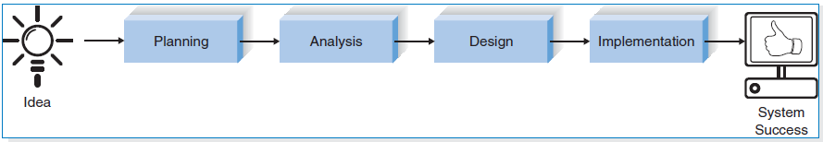
Figure1: The Systems Deelopement Life Cycle (Dennis, A., Wixom, B. and Roth, R. (2015).)
All the stages of SDLC are explained below.
Plan:
This is the fundamental stage of the SDLC [3]. Normally senior members of the team collect the information from different departments like Sales, Marketing and Business which is then used to prepare a project plan. This gives a financial overview of the business and also people involved and techniques need pick to deliver the project efficiently in closed budget. Planning for the quality requirements and risk assessments also done this phase.
Analysis:
Project stakeholders, business users and developers gather together during this phase to decide the requirements of the application [3]. Everyone has unique goal to understand each software requirement and project scope.
Most common questions that arise in this phase are:
- Who are the end users for the system?
- Where exactly and when the system is used?
- What will be the inputs and outputs for the system?

According to the given scenario, it’s clearly states that current manual system is very slow. The below are the key issues that are identified in the current system.
- No transparency in Sales
- Not reliable
All the above issues lead to money loss and reputation. Hence in this phase there is a need to identify best solution to resolve the existing issues. The new system proposed is to have the website to sell products online and a stock control system to manage the stock. Another big advantage of website is that customers can place their orders online instead of coming to the store or by phone. This saves lot of time for the staff and customer as there are no manual interventions. We can also get the feedback from the customer which helps to do further improvements.
For any company customer is heart of the business [7]. Any organization which gives better customer experience will always help in increasing sales. But in the current system sometimes telephone orders get delayed due to stock unavailability. In these cases John has to call the customers to apologize for sending the part order and he has to re-order the stock which in turn delays the delivery of the item to the customer. This always gets negative impact on business.
From analysis and by using some techniques like interviews, JAD, use case diagrams all these issues are grounded.
Design
System and Software design is finalized in this phase using the requirement specifications which is developed in the first phase. Software and hardware requirements materialized as part of design, this also helps to determine the system architecture. These specifications will also help testers to prepare test strategy and test plans [3].

Implementation
This is the phase where developers heavily involved and actual coding starts here. Requirement specifications are divided into small units so that developer produces the code. This phase is actually the biggest part of the entire software development life cycle which takes most of the time to build the proposed system [3]. Detailed design specification will always help programmers to produce the code quicker with less hassle [4]. Testing execution also done in this phase.
Software Methodologies:
There are different types of software process models as mentioned below [5]
- Waterfall Model
- Prototype Model
- RAD Model
- V-Shaped Model
- Spiral Model
- Iterative and Incremental Method
- Agile development method

Each of the above models has its own advantages and disadvantages. Based on the Project size, time allocated and number of other factors considered when choosing the right methodology. The below diagram will give the summary of some important criteria’s that need to be considered when selecting the appropriate model.

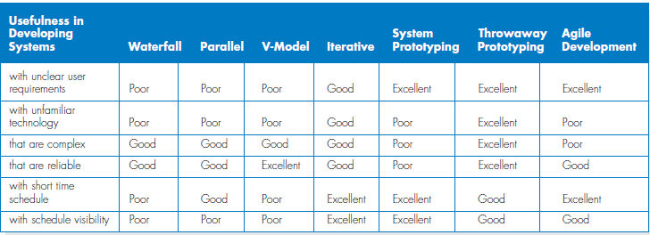
Figure 2: Criteria for Selecting methodology (Dennis, A., Wixom, B. and Roth, R. (2015).)

Chosen SDLC Methodology for Thomson Cycles:
As an analyst after analyzing the current system and complete research on software methodologies I came to a conclusion that Rapid Application Development methodology with Iterative model is best suitable to implement the Thomson new system. The main key point to choose this methodology is Time required to build the new system.
Reasons for Choosing RAD Iterative model
Iterative development model has been chosen for this project because it is suitable for complex projects with short delivery timescales. That rules out prototyping model since considerable time is spent in building a prototype which is discarded later. This is vital to revamp the business and start repayment of the loan within 5 years as per current plan.
The project will be developed and delivered in a series of versions [1], with every version resulting in a working prototype of the final product. Initial version will start off with basic functionality of the new system and features get added in subsequent versions. This is very essential for users (employees) to get familiar with the functionality at an early stage and provide feedback which can result in bugs or enhancements in later versions.
Iterative development can also accommodate new requirements late in the delivery cycle which can result in additional versions if they go over current estimates. This is advantageous when a project starts without a full specification of requirements and makes the approach flexible compared to waterfall model.
Iterative development involves close interaction with all stakeholders and users which is essential in this scenario, since they are moving from a paper based to an automated system. This is important since each employee is knowledgeable in his/her own area and can provide valuable inputs towards development.
The complexity of the project can be ascertained by looking at the functional modules that it requires:
- Leads/Prospect management – Record details of customers who phone in or check details on company website but don’t place an order.
- Sales – This is where customers place orders for bikes/clothing etc.
- Stock and integration with sales/service
- Product and pricing with discount options
- Customer billing (Direct Debit/Credit Card), Debt Collection (optional)
- Servicing and repairs
- Supplier order and invoicing
- User setup
Iterative development also has its drawbacks:
- Incomplete or inadequate problem analysis can lead to obvious and superficial needs will be addressed, resulting in inefficient practices being built in.
- Requirements may frequently change which significantly increases the product cost

Comparing the other methodologies with Iterative methodology
Waterfall methodology: This is a first process model introduced in 1970’s. This methodology follows sequential process where one phase completed at a time. If anything changes in between its need to be started from first phase. This is why waterfall is only suitable for the projects where requirements should be finalized long before project begins [6]. Keeping the time scale (3-4 months) for this project it is not recommend because takes more time for planning, gathering and analysis before phase of construction begins. Also there are no clear user requirements from John for the new system, so this methodology is not suitable. Also in any case if outcome of project doesn’t match the requirements of the business then again process need to be started from the beginning. Consumes time and investment will be increased.
Agile Methodology: This methodology is type of Incremental model [9]. Agile also not suitable for unfamiliar technology as Thomson business is going from paper based to IT based this is quite possible. The Project easily gets off from track if the user requirements are not clear and not sure about the final outcome [9]. Agile is more cost effective because requires high involvement of users. Due to lack of staff in organization getting staff out from daily activities and involving in analysis there is chance of slowing down the current system.
V-model methodology: This is also similar to the waterfall model. V-model stands for Verification and Validation model [8]. In today’s business process system should be delivered fast and very adaptable. As shown in figure 2 this model is un-suitable for the projects with unclear requirements, unfamiliar technology and short time scales. In this project there is a chance of causing unfamiliarity because company is moving into new IT based environment from paper based, so technology and requirements not familiar before starting the project. Also as said above time required for this project is very less, V-model is flexible for this kind of project.

Data Gathering Technique
System requirements can be determine by certain practices by analyzing and understanding the current System and implement new system. To gather the requirements analyst acts like detective. For gathering information JAD and interviews are selected as data gathering technique for the existing and proposed system [1].
JAD
Joint application development (JAD) is one of the facts collecting method where information will be gathered from all the staff including manager also can take ideas, concerns about the current system, based on their inputs the new system will be planned and implemented [1]. JAD sessions will be conducted by the JAD architect in this case analyst will act like JAD architect.
Currently Thomson cycle running with total 7 members of staff including manager (John) so it is very easy to invite all together to conduct a JAD session. During the meeting everyone are encouraged to share their views/ideas and concerns about the current system. Group work will always produce faster and efficient results when compared to Individuals working on their own. Main aim of this gathering is to collate ideas/issues from Staff of all levels, and to make note of all key requirements of the new system are well understood. Improvement can be shown in very less span of time using this technique. Primarily this method will not take much time unlike other methods (surveys and interviews).
Also in added to this it’s better to have interviews with one to one, because while conducting JAD session someone should handle the sales to keep business running. Also there may be chance of unavailability of staff due to long vacation/sick leaves and someone like Sally will not be able to attend this session as she works in weekends hence by scheduling one-one meetings no ideas would be left out and no other could feel their ideas were not considered. By Conducting one to one interviews with each person will make sure every idea/concerns will be noted by someone who are not able to express in front of manager/others.
JAD session will be scheduled by analyst and will be notified to every staff prior to meeting schedule. Staff members who are invited to JAD are:
- Thomson Cycle Owner/manager - JOHN
- Chief repairman - Vijay
- Jean - Office staff, who takes care of the stock ordering and handles the financial transactions.
- Shop keeper- GED, His ideas also vital about the new system.
JAD session Preparation:
Facilitator be responsible for providing the meeting agenda, guidelines, Session plans, rules and objectives.

JAD session agenda:
The key agenda of JAD is to make up of questions that would be asked and provision of time for each question to converse. Facilitator make sure that everyone involves and also will not allow to dominate the session by certain people of project.

- View the allocated budget for new system.
- How much storage for data is required?
- Abilities of new business No Asthma to be understand.
- How many orders will be placed in a day? and who will be handling calls?
- How long the process of taking the order through telephone is carried out?
- How the telephone payment orders are processed, what kind of process involved in it?
- What sort of data is captured to store when customer placed an order? Audit the receipts and invoices to trace it.
- How efficiently invoice of suppliers are quoted?
- Current stock system problems.
- How stock levels are getting managed?
- How much price is quoted for repairs? During price quoting are they using criteria?
- How to secure the new system?

Guide lines:
- Invitees should be available on scheduled time at designated meeting room.
- Active participation is required from each individual.
- Everyone will be allocated for 10-15 minutes not more than that to share their views
- When others are speaking don’t try to interrupt.
- To explain the views in depth use white board in room.
JAD session objectives:
- Initial discussion on project brief.
- To enable everyone to express their ideas in front of everyone. So that ideas can be exchanged well among staff so that process can be improved better.
- To get clear understanding of the running system.
- New system requirements will be analysed and organised effectively.
- To develop problem risk and tracking method.
- Get more understanding of everyone role in the company.
- Trace out the current system faults and area where causing the poor performance.

Interview
To gather the information for either new system or current system from individual, most commonly used process is interview. The main constrain for this process is time. This can be managed by interviewing many people at same time. Interviews will also take place for the people who are not comfortable to express their view openly in front of managers these are organized privately with analyst. This is very essential because people working at different level have different views. This kind of approach provides full knowledge before going through specifics.

Interviewee Selection
Staff Name | Designation | Purpose of Interview | Meeting Time
John | Manager/Owner | Brief explanation of Current system overview and new system requirements | Mon 10am – 12am
Vijay | Chief Repairman | Issues related to repairing items and stock issues, delivery. | Mon 2pm – 4pm
Jean | Invoice check and Stock handling. | Invoice, stock, supplier related issues | Tue 11am – 1pm
Ged | Counter and developer | New system ideas and current system issues. | Wed 1pm – 4pm
Sally | Store keeper(part-time) | Understanding of existing system and enhancements that can be made to it. | Sat 11am – 1pm
Interview question Designing
Closed Ended Questions
- Number of orders per day by telephone system?
- Every month how many invoices repeatedly send?
- No of Trade customers?
- How to resolve the stock related issues?
Open Ended Questions
- Is the system for generating invoice is efficient? How this can be improved?
- What is current stock system problem?
- What causing the problems for telephone orders?
- What are the major difficulties in new system built?
- How you get indication when stock is low?
Probing Questions
- Is it difficult for repair price to quote? Why?
Conclusion:
Ideas and current issues facing by system are noted clearly. Detailed report is prepared after the interview to club the all ideas and views which helps to plan the new system in efficient manner.
In General for large scale companies surveys questionaries’ will help to understand the currents system issues and requirements of a new system where as Thomson Cycle is a small organization where ideas can be taken in one single secession and interviews will be taken to get clear understanding from everyone.

Requirements
Requirement of the system is defined as perform the system requests needed by business in to more detail which means what system must do in order to gain profits to the business. In other words to gain profit to the business system must have some characteristics and the system must perform some activities automatically to reduce manual intervention. A function is defined as a set of inputs, the actions, and amount produced.
Functional requirement: Functional requirement outlines a function of a system or its element. It is sub classified in to 2 categories as Process oriented and Information oriented.
I have listed the functional requirements for the new system of Thomson cycle below.
Functional Requirements |  |  | Requirement specification
Type | Description | Actions | Requirement specification
Process Oriented | A process the system must perform;  A process the system must do | Allow customers to search for the products they wish to purchase in the website. | - Customers should be able to search for product with Product code, name etc.  - Customers should be able to view all products based on different categories.  - Customers should be able to see the complete product information like brand, colour, price, Images and warranty etc.  - Customers should be able to refine their search based on Brand/Category/Price range etc.
Process Oriented |  | Website should allow the Customer should be able to register and login to account | - System should allow the customer to register for new account  - System should send authentication email to the customer to activate the account after registration  - System should allow the customer to update customer details like Address and Contact details etc.  - Customers should be able to reset account password/unlock account if they want.
Process Oriented |  | Customer should be able to Purchase the items on website/In store | - System should allow the customer to add any number of items to the basket before proceed to the payment.  - Customer should be able to update basket at any time.  - Customers should be able to see stock availability as well.  - Customer should see expected stock date for out of stock items.  - Customer should be able to proceed to purchase item as a guest so that they don’t need to create account.  - Customer should be able to make payments using different payment methods (Credit card, Debit card and Pay pal etc.).  - Customer should be able to deliver the item to any address.  - Customer should receive order confirmation Email after placing order.  - For In store purchases all the Items should be scanned by the barcode reader and system should recognises the item details (price, availability etc.) based on Item code.
Process Oriented |  | Customer should be able to track the order status on website | - Customer should be able to track their order to see whether the dispatched or awaiting order etc.  - Customer should be able to view their expected delivery date.
Process Oriented |  | Customer should be able to make enquiry/place orders over telephone | - System should allow the office staff to search for any item price/stock availability in inventory system for the telephone enquiries.  - System should allow office staff to place orders made by Customer over the phone and print invoice.  - System should allow the staff to update paid invoices for the telephone orders.
Process Oriented |  | Customers should be able to get their items repaired in store | - System should allow Chief staff to prepare/adjust quote for the repair of an item.  - System should allow staff to take payments for accepted quotes once item is repaired.  - System should automatically send repeat invoice to the indirect customers who doesn’t pay the first invoice within a month.
Process Oriented |  | Customers should be able to Place custom built bike orders | - System has capacity to record custom built bikes to requirements of customers.
Process Oriented |  | Trade customers should get 15% discount on any item that they purchased | - System should allow the staff to apply 15% discount to the trade customers once they verify their details in business customer database.
Process Oriented |  | System should allow the staff to place stock order to the supplier and update stock details in the Inventory system | - System should allow the staff to place orders to the supplier  - System should allow the staff to Update new stock into inventory system which will automatically updates in the website as well.
Process Oriented |  | System should allow the staff to track any order details/status | - System should allow the staff to track any order details/status for any customer (Direct/Indirect).  - System should allow the staff to reprint/resend invoices to the customer.
Process Oriented |  | System should allow the Promotional code/voucher to be applied when placing order | - System should be able to validate the voucher codes applied by customers for website/telephone orders  - System should be able to display any promotional offers/discount on any products in the website.
 |  | System should automatically update inventory stock system when the item is sold and generate daily sales/ stock reports | - System automatically have to update the existing stock list  - System has to warn when level of stocks are low.  - Individual credentials have to create for each staff. It allows recording the sales made by each individual
Information Oriented | Information the system must contain | System should store any Customer data, Orders history, Payments and invoices for at least 5 years | - System should maintain the Customer data, order history in the customer database for at least 5 years  - System should store all the invoices in Invoice database for at least 5 years.  - System should maintain all the online payment transactions info in the payment database.  - System should have the all the trade customers details in business customer data base.
Information Oriented | Information the system must contain | System should store any Supplier orders, In store Sales for at least 5 years | - System should record all the supplier orders and invoices  - System should record all the in store sales and store it in Payment database
Information Oriented | Information the system must contain | System should store the all the expenses for the last 5 years | - System should store all the expenses including Employee salaries. So this helps to forecast the business revenue

Non-functional requirement:
Non-functional requirements specifies how the system performs specific function. These are the requirements that specifies the criteria to judge the operation of a system [10]. Non-functional requirements are very important as they may affects the Customer Experience. These requirements also differentiate whether project success or fail because it specifies the System characteristics and limitations.
There are two main categories in Non-functional requirements:
- Execution: Any non-functional requirements which can be observed at run time such as security and usability [10]
- Evolution: These are static in nature for example Capacity, Maintenance, testability and scalability [10]
Non- functional requirements for the new system categorized as below
Non-functional  Requirements | Description | Requirement specification
Speed | Performance of the system | - Application must respond to the users within a  reasonable time frame.  - Website should be available all the time without interruptions.
Security | How System stores personal info and access levels to the system | - The details of customers should be well protected.  - Log in facility should be provided to prevent unauthorised access to the application.  - Customer Payment information should be PCI  compliance and well protected.
Operational | Compatibility with other systems | - System should Support all web browsers and mobile devices [1]  - System Should be integrated with stock control system
Recovery | Backup and Recovery process | - System should be recovered immediately in case of disaster
Capacity | System Capabilities such as Throughput, Storage | - Website should handle the high loads of visits at any time
Regulatory | Organization should follow the government policies | - The application must abide with government policy that regulates the industry such as Data Protect Act, Computer use Act et.
Staff Training | System documentation which helps in training | - The staff needs to be trained on how to use the proposed system when completed

Group meeting discussion
Group meeting discussion for Task 1: A group got together to decide on the software development methodology based on scores assigned to them. The above matrix (Figure 2) shows how the group evaluated each method against factors in Column 1 which eventually led to the final decision.
Group meeting discussion for Task 2: While selecting Data gathering techniques, we have considered each technique with respect to the new system to be developed and found JAD and interview techniques could help better to solve an existing problems as well as meet a market place demand to progress efficiency and profitability.
Group meeting discussion for Task 3: While defining requirements for the new system we have concluded to the written requirements in the report keeping the existing system in mind. The brief description and the reason why we have selected the respective methodology, techniques and requirements are written in the report.

Use Cases
Please find the use case diagram and description for the two of the use cases below.
Use Case Diagram:
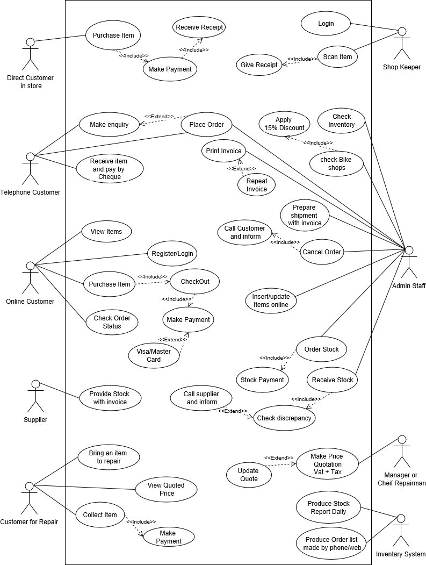
Place telephone orders Use Case Description:
Use Case Name: Placing Telephone Orders |  | ID: uc-1 | Importance Level: High
Primary Actor: Customer
Short Description: This use case describes how a telephone order can be made.
Trigger: Customer want to purchase items from Thomson Cycle through phone call.
Type: External / Temporal
Pre-conditions:
- Customer should call designated number to buy products during the business hours.
- Ordered item should be within the list of products offered by the company.

Major Inputs:  Description Source  Item details Customer  Item Quantity ____________ Customer  Customer details ___________ Customer  Shipping address Customer  Payment details __________ Customer | Major Outputs:  Description Destination  Item Availability Inventory System  Invoice Invoice database  Invoice Customer  Item Customer
Major Steps Performed  1. Call to designated number to enquire about the required parts  2. If the required item is available then customers place an order.  3. Part will be received with invoice  4. Payment will be done through Cheque |  |  | Information for Steps  - Item details  - Check inventory system and Order item  - Receiving Item  - Payment done.
Post-conditions:
- Items will be purchased through telephone orders.
Exception:
- Staff will phone customer and apologies if the purchase items are not available in the stock.

Submit item for repair Use Case Description:
Use Case Name: Submit item for repair |  | ID: uc2 | Importance Level: High
Primary Actor: Customer
Short Description: Customer will bring the bike to shop for repair or service then Manager/Chief Repairman will make the initial Quotation with VAT+TAX.
Trigger: Customer want his bike to be repaired.
Type: External / Temporal
Pre-conditions:
- Check if the faulty parts are available in stock.
- Check if there is a resource labour available to do the repair within stipulated time frame.
Major Inputs:  Description Source  Repair details ___________ Customer  Initial quote __Manger/Chief repairman  Customer details Customer  Adjusted Quote Manger/Chief repairman  Payment details Customer | Major Outputs:  Description Destination  Quote details ___________ Quotes database  Customer Information Customer database  update stock list Inventory database  Transaction details Transactions database
Major Steps Performed  - Submit item for repair  - Get price quotation for the repair item  - Make Payment  - Collect the item |  |  | Information for Steps  Faults in the item  Parts  Payment details  Delivery
Post-conditions:
- If any additional problems identified in the repair or additional parts required then
quote will be adjusted.
- Collect Payment when Customer collects item.
Exception
- When there is no part to fulfil the repair, advise the customer accordingly and order for the parts to be used for the repair
- When there is no labour to fulfil the repair, advise the customer accordingly when labour will be available for the repair
- When there is hidden problem this entails adjusting the price quotation.

Dataflow Diagram
A painting is worth a thousand words. Using Data Flow Diagrams (DFD’s), system process can be explained well rather than writing it in paragraphs. DFD is a graphical representation of the steps performed in the system to complete any activity. With the clear picture of DFD system requirements can be formulated and presented well to the end user. It elaborates the process like how it enters and leaves the system [11].
It can be used as a communication tool between a systems analyst and Thomson cycle which acts as initial step for restructuring the system. Below is the DFD for the Thomson Cycle [11].
DFD will start with context diagram which explains about the entire system. It defined how the system will communicate with users (external entities).
Context Level Diagram:
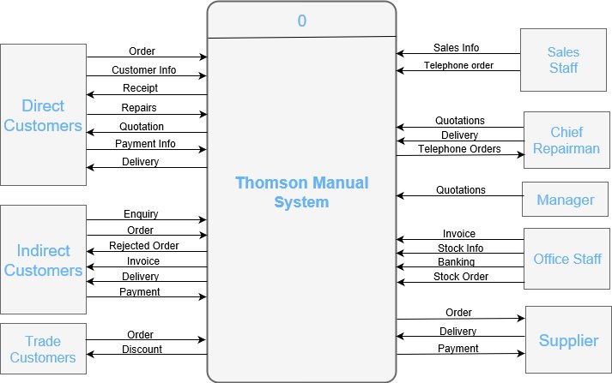

Level 0 Data Flow Diagram
The next level in the DFD will be Level 0 diagram which shows all major things like external entities, Process, data stores.
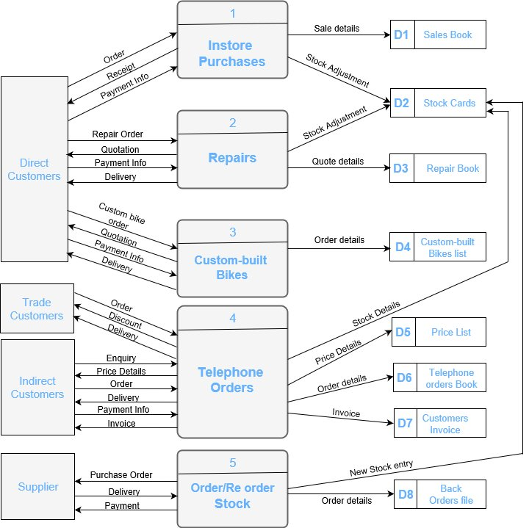

Level 1 Data Flow Diagram
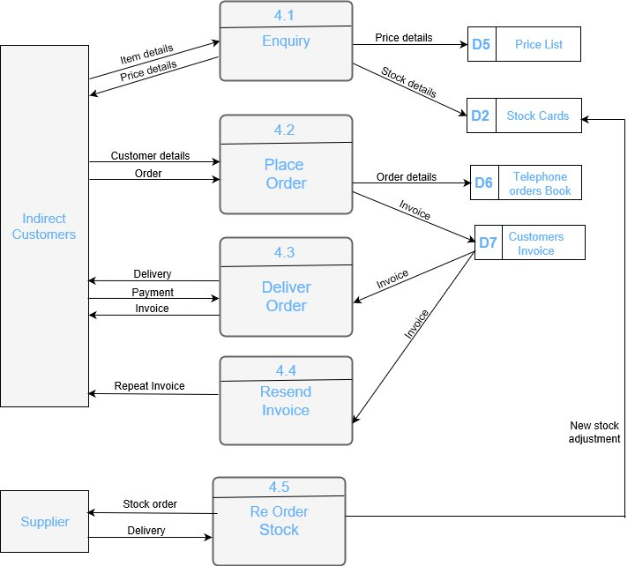

References
- Dennis, A., Wixom, B. and Roth, R. (2015). System analysis & design. 6th ed. Hoboken, NJ: Wiley.
- Tegarden, D., Dennis, A. and Wixom, B. (2013). System analysis design UML version 2.0. Singapore: Wiley.
- Jobawareness.com. (2017). Top Four Skills Required in a Systems Analyst [online] Available at: http://www.jobawareness.com/four-skills-systems-analyst [Accessed 02 Nov. 2017].
- www.tutorialspoint.com. (2017). SDLC Overview. [online] Available at: https://www.tutorialspoint.com/sdlc/sdlc_overview.htm [Accessed 05 Nov. 2017].
- Level, I., Tutorial, A., Dates, 2., Tests, I., Us, C., Policy, P., Use, T., Us, A., us, W., Vasagiri, S., BHALLA, A. and Jawalkar, A. (2017). What are the Software Development Life Cycle (SDLC) phases?. [online] Istqbexamcertification.com. Available at: http://istqbexamcertification.com/what-are-the-software-development-life-cycle-sdlc-phases/ [Accessed 05 Nov. 2017].
- Mohamed Sami. (2017). Software Development Life Cycle Models and Methodologies. [online] Available at: https://melsatar.blog/2012/03/15/software-development-life-cycle-models-and-methodologies/ [Accessed 15 Nov. 2017].
- Destination Innovation. (2017). Who are a company's most important stakeholders?. [online] Available at: http://www.destination-innovation.com/who-are-a-companys-most-important-stakeholders/ [Accessed 10 Nov. 2017].
- Level, I., Tutorial, A., Dates, 2., Tests, I., Us, C., Policy, P., Use, T., Us, A., us, W. and kumar, a. (2017). What is V-model- advantages, disadvantages and when to use it?. [online] Istqbexamcertification.com. Available at: http://istqbexamcertification.com/what-is-v-model-advantages-disadvantages-and-when-to-use-it/ [Accessed 11 Nov. 2017].
- Level, I., Tutorial, A., Dates, 2., Tests, I., Us, C., Policy, P., Use, T., Us, A., us, W., Ali, L. and A, v. (2017). What is Agile model – advantages, disadvantages and when to use it?. [online] Istqbexamcertification.com. Available at: http://istqbexamcertification.com/what-is-agile-model-advantages-disadvantages-and-when-to-use-it/ [Accessed 13 Nov. 2017].
- W. (2017). What is functional and non functional requirement?. [online] Stackoverflow.com. Available at: https://stackoverflow.com/questions/16475979/what-is-functional-and-non-functional-requirement/16476014#16476014 [Accessed 16 Nov. 2017].
- Visual-paradigm.com. (2017). What is Data Flow Diagram (DFD)? How to Draw DFD?. [online] Available at: https://www.visual-paradigm.com/tutorials/data-flow-diagram-dfd.jsp [Accessed 17 Nov. 2017].

SOFT40091 - Systems Analysis and Design
Peer Appraisal of Individual Participation

Name: PURNIMA MALNEEDI (N0768969)
Although the tutor will have awarded a grade for the group’s SysA&D Coursework, the actual grade an individual group member receives is dependent on their average peer appraisal score.

Please complete EITHER section A or B

Section A
All group members contributed equally to this project (and deserve a 3)

Section B

In the table below, please rate the contribution made by each of the other group members (scoring from 0 to 3).
Student Name | Score
Shason Gurung (N0773543) | 3
Arpan Upadhyay (N0769243) | 3
Tayyab Hayat (N0773611) | 3

3 – Contributed sufficiently well (attended all/most meetings, produced deliverables on time to expected standard)
2 – Contribution was variable (missed some meetings but produced most deliverables – standard may have been lower than that of the group)
1 – Insufficient contribution (missed numerous meetings and/or typically did NOT produce expected deliverables or produce them to an acceptable standard)
0 – Little or no meaningful contribution
If the average peer appraisal score is 2 then a two grade penalty or a Low Fail will be given for the group tasks (whichever is higher); else if the average score is 1, then a three grade penalty or a Low Fail will be given for the group tasks (whichever is higher). An average score of 0 will result in a Zero grade being awarded for the group tasks.

